**MID: M1070348**

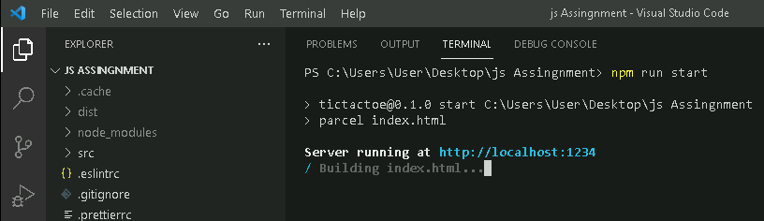

Open the url to see the output of the game in browser.

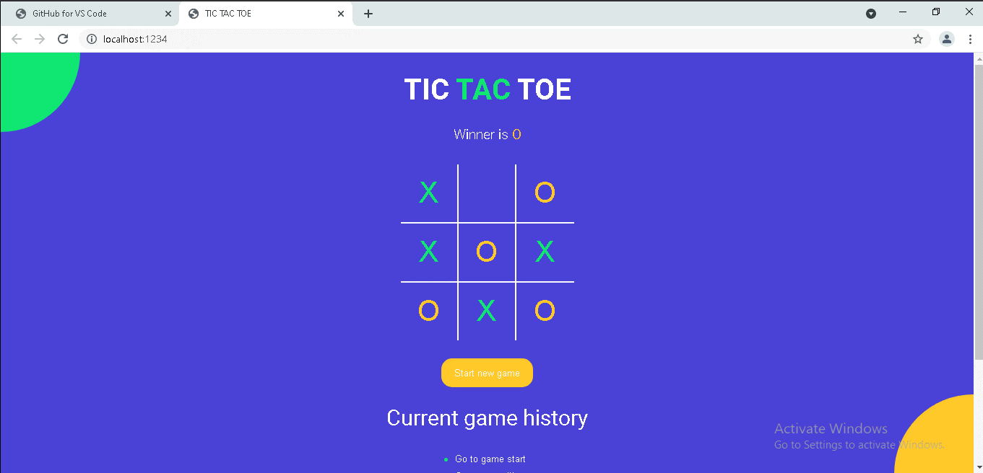

The above assignment is done use react and Node package manager.

Git hub url:

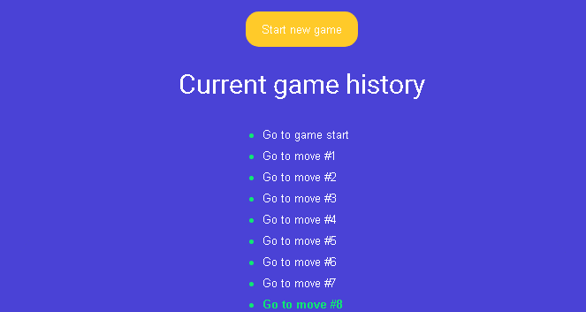

This also gives the game history.

**How to run the code and verify:**

**Step 1:**

Clone from github: “git clone <https://github.com/saimadhu2017/JS-Final-Assignment.git>”

**Step 2:**

Install dependcies by using the below command.

“npm install “

**Step 3:**

Run the command below to see the url and open it in browser.

“npm run start”